
My Target: / 24 or ____% Class Target: ___%

Name: ___________________________

Year 11 ATAR GEOGRAPHY (2021) – Weighting 2.5%
Task 6 – In-class test based on Geographical skills/mapping skills. (Timed/Test Conditions). TOTAL = 24 Marks

Time Allocation: 5 minutes reading time and 40 minutes working time

PART A: Multiple Choice – Circle the correct letter ( / 10 marks)

How many Multiple Choice have I answered correct? ______ / 10

Refer to Source 1: Aberdeen Topographic map to answer Questions 1 to 10

Note : GR = Grid reference, AR = Area Reference.

- The scale of the topographic map (Source 1) expressed as a ratio is

- 1:25 000
- 1:50 000
- 1:100 000
- 1:250 000

- The landing ground found in grid square AR 9537 has been constructed

- on a spur facing north
- on a saddle with a small hill
- in a valley facing south
- on a plateau between two rivers

- The slope found between point A (GR 005363) and point B (GR 025364), and marked by the red transect line, is best described as a

- uniform and concave slope
- uniform and convex slope
- mainly convex slope
- mainly concave slope

- A car travelling north along the New England Highway from Muswellbrook to Scone takes 18 minutes to complete the journey. The average speed of the vehicle is nearest to

- 60 km/h
- 80 km/h
- 100 km/h
- 120 km/h

- The cultural feature located in grid square AR 9531 is a

- spot height/elevation
- small hill
- perennial watercourse
- tank or small dam

- Point D on Source 2 best corresponds on Source 1 to Grid Reference

- GR983363
- GR990385
- GR995352
- GR967397

- The difference in height between the horizontal control point on the summit of Bells Mountain (AR 0832) and the building at GR 973376 is nearest to

- 510 metres
- 689 metres
- 855 metres
- 945 metres

- After travelling on a bearing of 160 degrees for approximately 4 kilometres from point B (GR 025364) you would be nearest to

- the rural settlement of Pastime (AR 9932)
- Colonel Mountain (AR 0737)
- an institution for delinquent boys (AR 0433)
- the built-up area of Aberdeen (AR 0139)

- The area in hectares of the vineyard/orchard indicated by point C on the map
(GR 010315) is nearest to [Note: There are 100 hectares to a square kilometre.]

- 85 hectares
- 65 hectares
- 45 hectares
- 25 hectares

- The co-ordinate of 35º 00’ S, 139º 00’ E on the map of Australia (Source 4) best corresponds to

- Hobart
- Melbourne
- Adelaide
- Sydney

Section Two: Short response (14 marks)
Refer to Source 1: Aberdeen topographic map to answer Questions 11 to 14.

Question 11 (4 marks)

Using information from Source 1 and Source 4 describe the location (situation) of the settlement of Aberdeen.

Source 1: __________________________________________________________________
_______________________________________________________________________________________

_______________________________________________________________________________________

Source 4: __________________________________________________________________
________________________________________________________________________________________

________________________________________________________________________________________

Question 12 (2 marks)

Calculate the average gradient of the slope along the transect line found on Source 1 between point A (GR 005363) and point B (GR 025364).

NOTE: Calculation must be shown to gain full marks.

________________________________________________________________________________________

________________________________________________________________________________________

________________________________________________________________________________________

________________________________________________________________________________________

________________________________________________________________________________________

________________________________________________________________________________________

________________________________________________________________________________________

________________________________________________________________________________________

Question 13 (4 marks)

Using information from Source 1 and Source 2, identify and describe two characteristics of the site of the settlement of Aberdeen.

Site characteristic 1 ___________________________________________________________________
________________________________________________________________________________________

________________________________________________________________________________________
________________________________________________________________________________________

________________________________________________________________________________________
Site characteristic 2 ___________________________________________________________________

________________________________________________________________________________________
________________________________________________________________________________________

________________________________________________________________________________________
________________________________________________________________________________________

Question 14 (4 marks)

Annotate the cross section below by accurately placing on the position of the following features:

- New England Highway
- Browns Mountain
- Scandal Horse Farm access road
- Hunter River

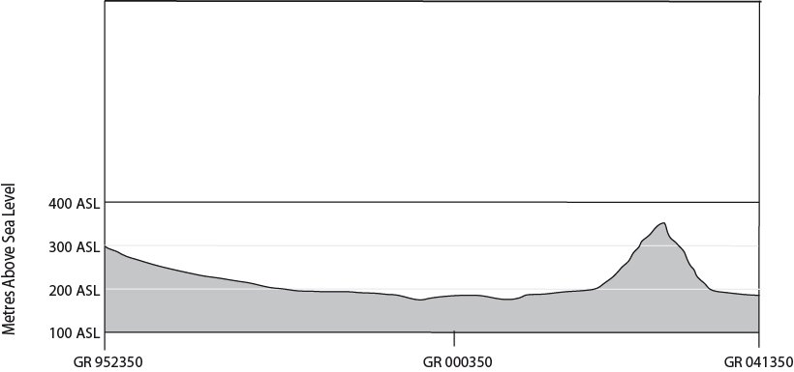

End of test paper

